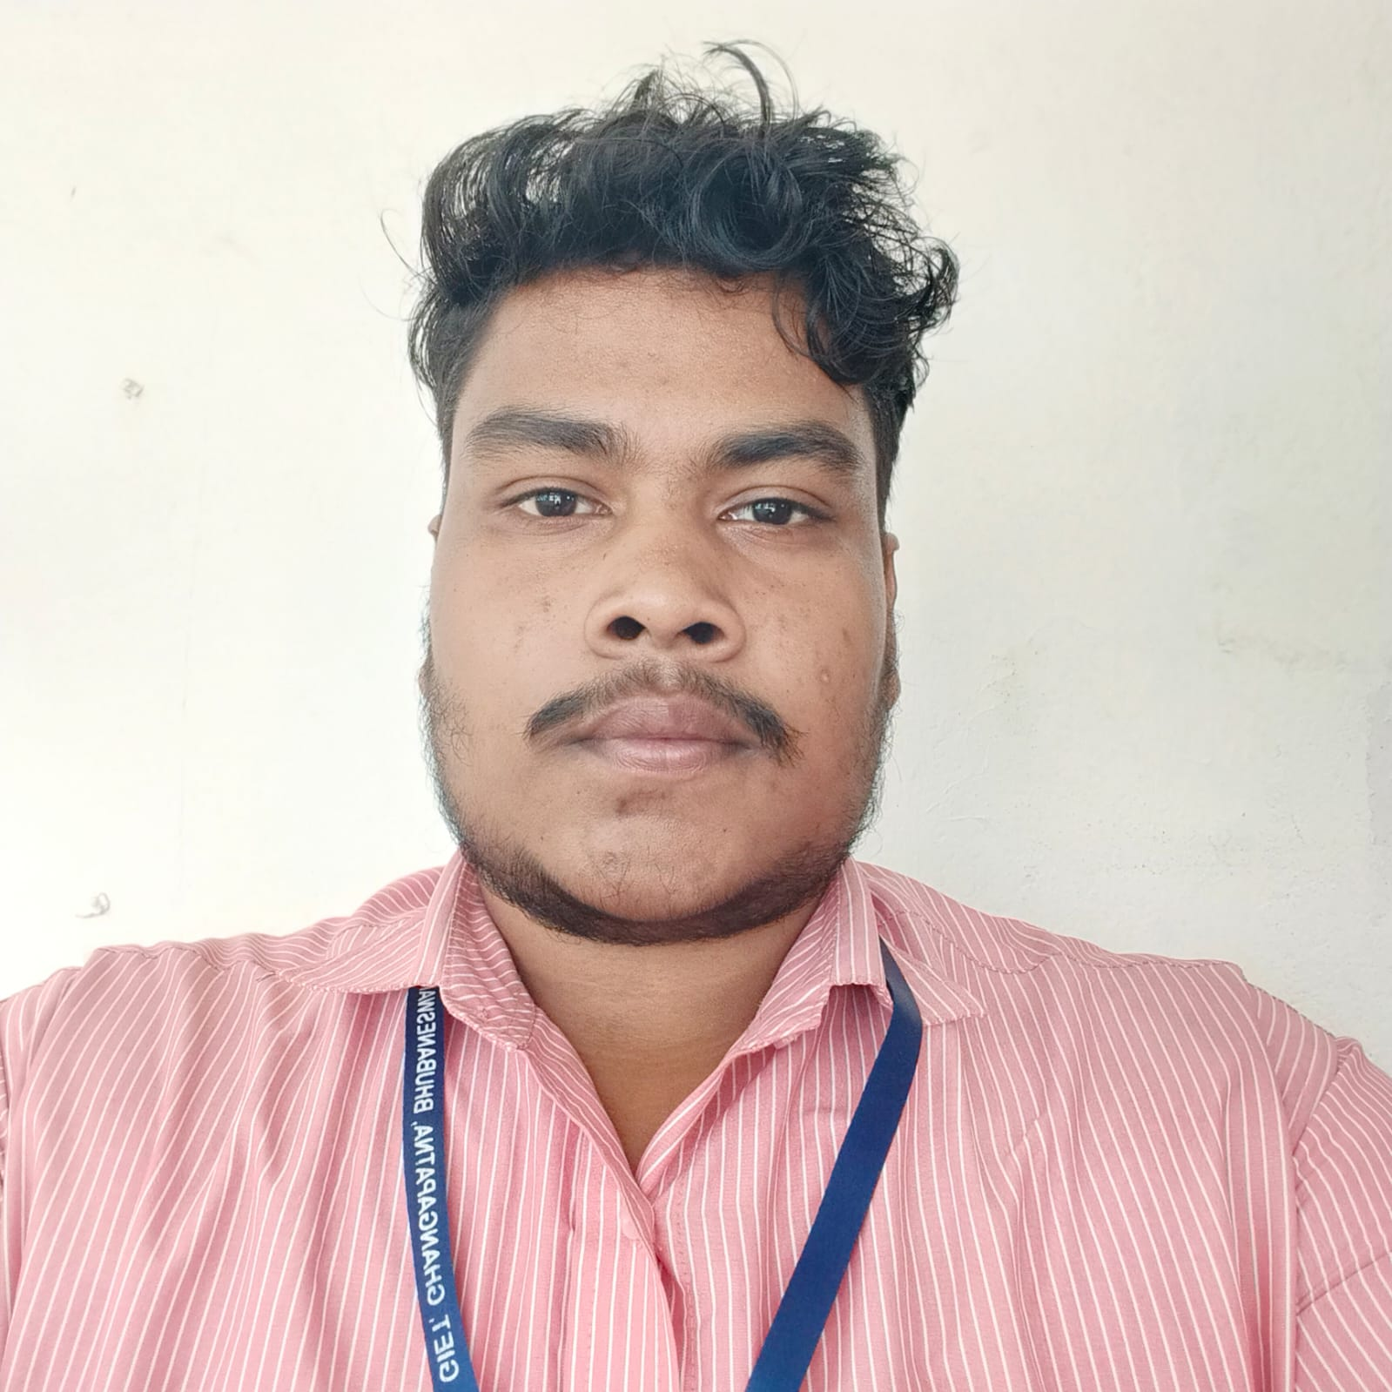

ADD COLLEGE FORMAL PHOTO HERE

**Name:- Srikshetrabasi pradhan**

Mechanical Engineering

Email: srikshetrabasipradhan@gmail.com

Phone: +91 6370232186

**Career Objective**

To be a part of an organization where I can show case my skills and can fully utilize it and make a significant contribution to the success of the employer and at the same time my individual growth.

**Educational Qualifications**

|  |  |  |  |
| --- | --- | --- | --- |
| Degree and Year | Institute | Board | Marks/CGPA |
| B.Tech(CSE) | Gandhi institute of excellent technocrats | BPUT | 7.30 |
| +2 Science in 2020 | Anchalika Mahavidyalaya | CHSE | 44.66% |
| 10th in 2018 | Judhister Bidyapith | BSE | 58% |

**Technical Skills**

Basic of C, java,,HTML, CSS, Javascript,

**Personal Details**

|  |  |
| --- | --- |
| Date of Birth | 01/12/2002 |
| Gender | Male |
| Father's Name | Jay Pradhan |
| Address | At- dhodapalli, Jagannath Prasad, Ganjam, 761121 |
| Alternate phone number | 6370232186 |
| Language Known | English,Hindi, Odia |
| Interests & Hobbies | Cricket, workout |

Place: signature

Date: